ContactManagement_Verify Contact notes _Instance44_12-Jul-2018_05-30-54_AM_SingleSignOn.png

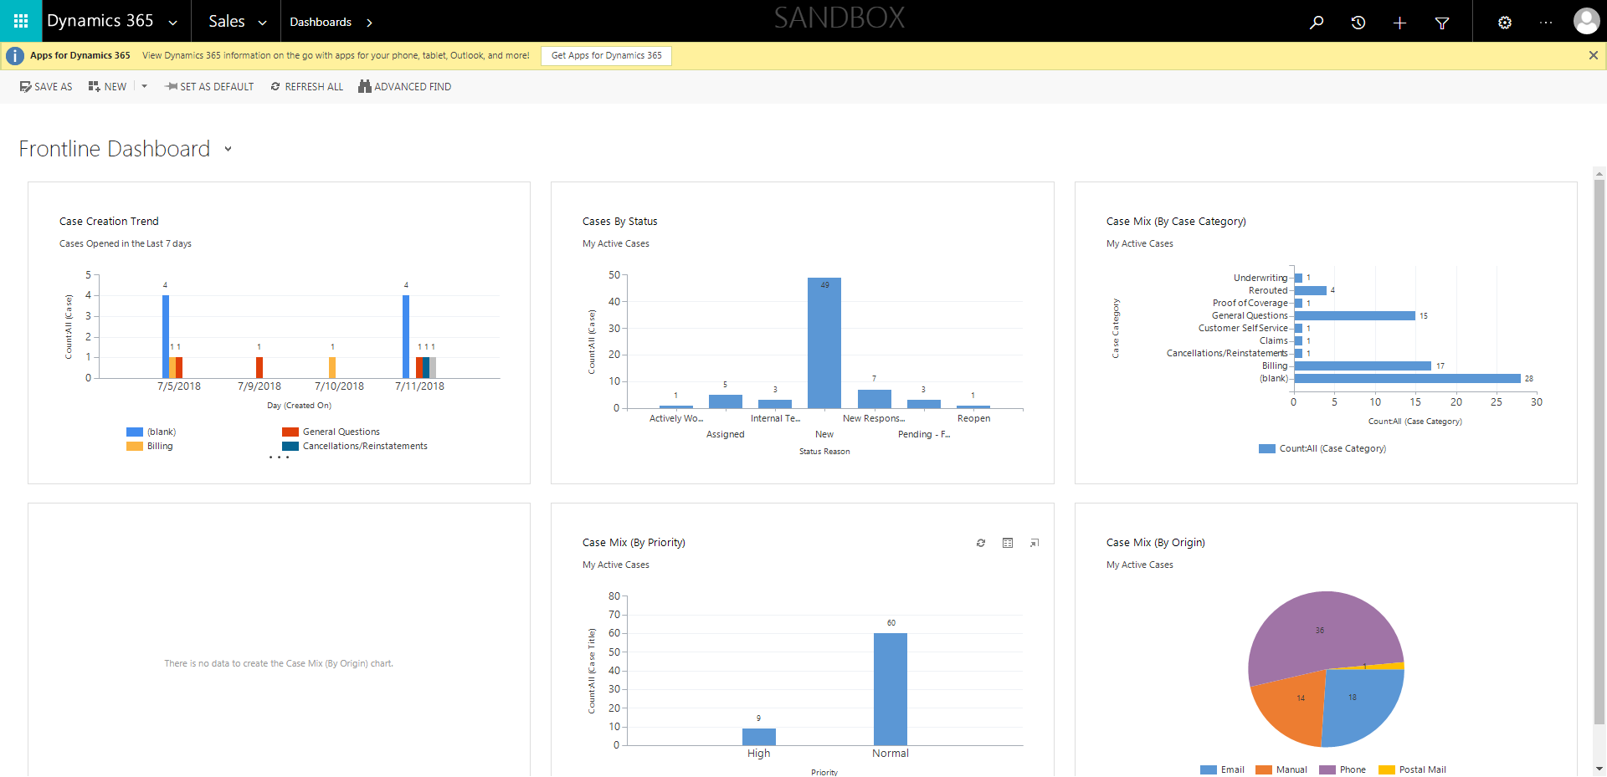

ContactManagement_Verify Contact notes _Instance44_12-Jul-2018_05-30-34_AM_MouseClickActiononStaleElement.png



ContactManagement_Verify Contact notes _Instance44_12-Jul-2018_05-32-05_AM_VerifyingAllNotesofanindividual.png

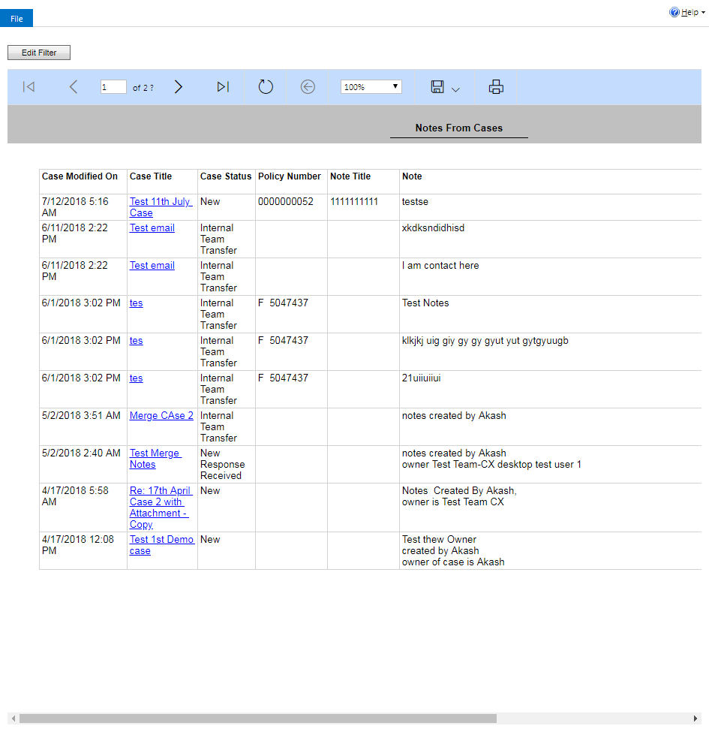

ContactManagement_Verify Contact notes _Instance44_12-Jul-2018_05-30-49_AM_SingleSignOn.png

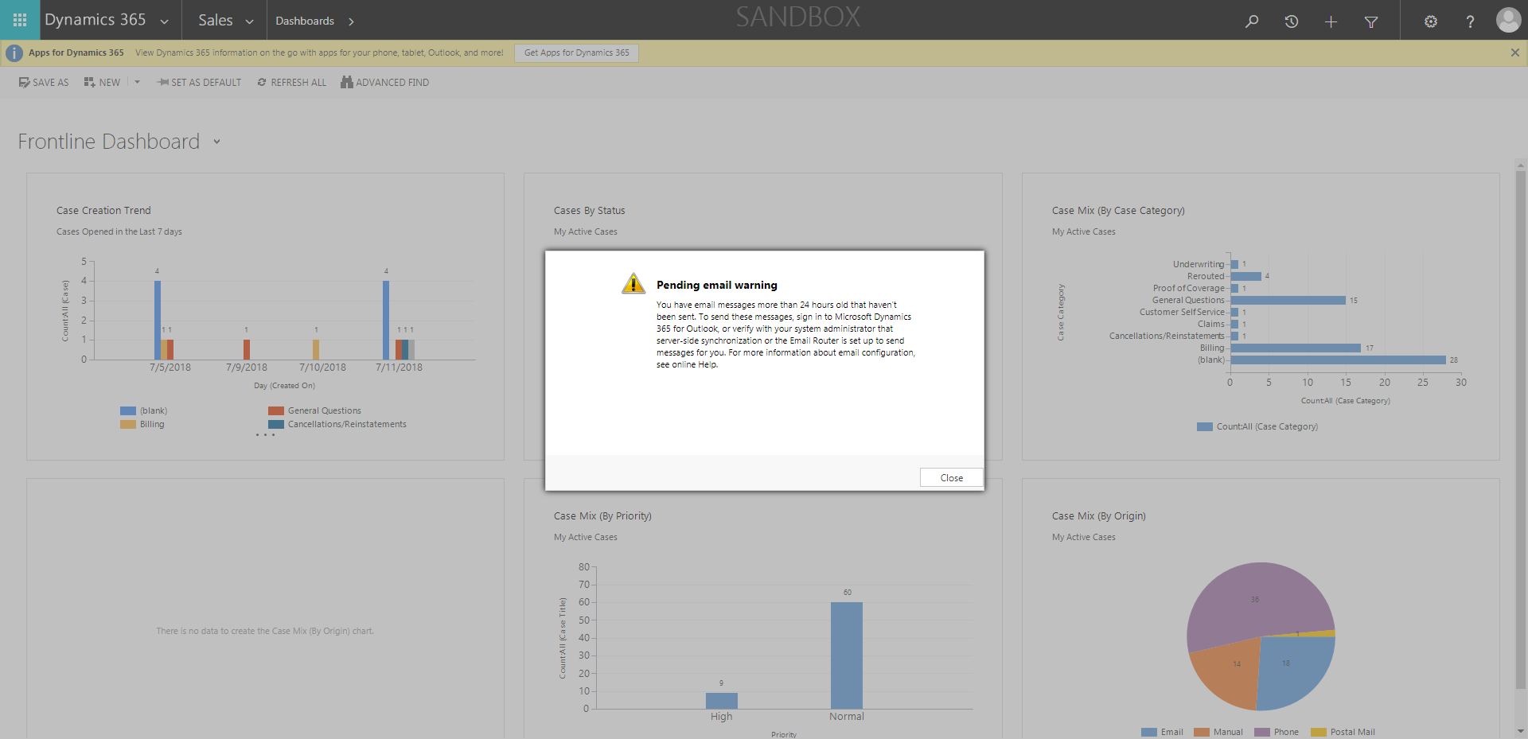

ContactManagement_Verify Contact notes _Instance44_12-Jul-2018_05-30-36_AM_EnterTextAction.png



ContactManagement_Verify Contact notes _Instance44_12-Jul-2018_05-31-58_AM_Validatingcontactentitynavigation.png

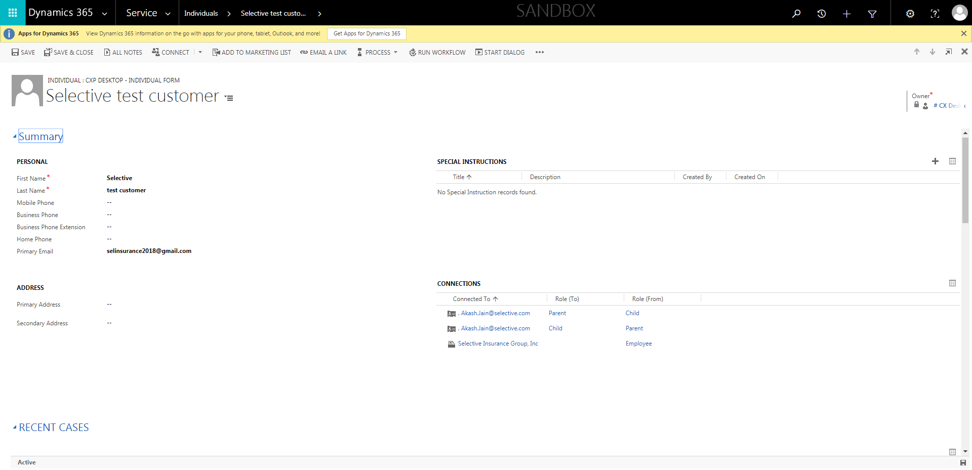

ContactManagement_Verify Contact notes _Instance44_12-Jul-2018_05-32-03_AM_VerifyingLatestNotesofanindividual.png



ContactManagement_Verify Contact notes _Instance44_12-Jul-2018_05-30-37_AM_MouseClickActiononStaleElement.png

